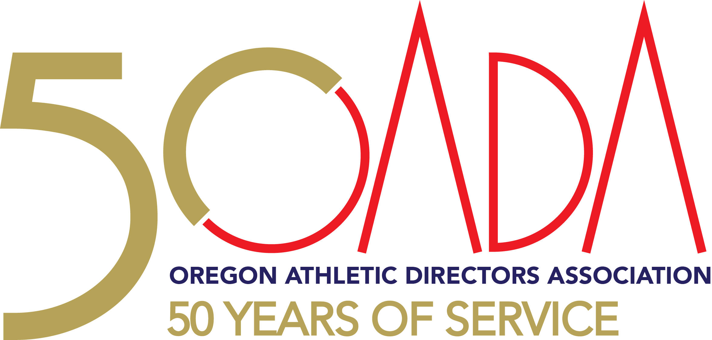
OADA State Conference

April 12-16, Sunriver Oregon

FRIDAY, APRIL 12

Time Activity Location

3:00 – 4:30p OADA Executive Board Pre-Conference Meeting with Sunriver Staff Gallery Room

5:00 – 9:00p LTA CLASSES

LTC 790 Leadership Training Instructional Methods and Techniques Landmark II
Tim Sam, North Valley HS, & Kris Welch, OSAA, Dave Hood, OADA

LTC 504 Legal Issues I (Liability for Sports Injuries & Risk Management) Landmark I
Lynn Cowdrey South Wasco & Sandy Luu, Catlin Gabel

9:00 – 11:00 OADA Executive Committee Meeting/Packet Stuffing Gallery Room

SATURDAY, APRIL 13

Time Activity Location

8:00a- 12 Noon LTA CLASSES

LTC 508 Legal Issues III (Hazing, Constitutional Law, Disabilities Law, & Heritage I

Employment & Labor Law)

Kris Welch, OSAA & Lynn Cowdrey, South Wasco

LTC 799 Standards of Excellence in Athletic Programs Heritage II
Steve Wallo, C.S. Lewis & Dennis Burke, Wilsonville

LTC 703 Student Centered Performance beyond X’s and O’s Landmark I
Sandy Luu, Catlin Gabel & Vicki Nelms, Clackamas

LTC 611 Promoting, Marketing, and Fundraising Landmark II
Kevin Bryant, Redmond Schools

Noon – 1:00p OADA SCHOLARSHIP GOLF TOURNAMENT REGISTRATION-$85 Crosswater
and 50/50 Tickets

1:00 – 6:00p OADA SCHOLARSHIP FUND GOLF TOURNAMENT Crosswater

6:00 – 7:00p 19th Hole Festivities following the Golf Tournament sponsored by Beynon Sport Surfaces Crosswater

1:00 – 6:00p Early Packet pick-up-ONLY FOR MEMBERS WHO PRE-REGISTERED AND PAID Homestead Lobby

6:00p League Meetings

SUNDAY, APRIL 14

Time Activity Location

7:00a – 12:00 Vendor Check In/Set-Up) Homestead

7:30 – 8:30a REGISTRATION Homestead

8:30 – 10:45a BREAKFAST BUFFET sponsored by Oregon School Activities Association Great Hall

CONFERENCE OPENING SESSION
Welcome Dennis Burke, Wilsonville HS, OADA President
Introduction of Sponsors Craig Rothenberger, CAA, Co-Executive Director
OSAA: Year in Review Peter Weber, OSAA Executive Director
Introduction of Candidates Doug Thompson, OADA Secretary
Keynote Speaker Adam Bradley, Lead Em’ Up

11:00-2:00p OADA/State Ambassadors Fireside

11:00 – 11:45p Workshop Session #1

A. Common Title IX Concerns Landmark I
Presented by Kelly Foster, OSAA and K.T. Emerson, OSAA

B. New AD’s: Transitioning Into A New School/Community Landmark II
Presented by Neil Barrett, Jefferson HS

C. Football Update (ad-hoc, state of football, etc.) Heritage I
Presented by Brad Garrett, OSAA, Tony Smith, St. Paul, & Rob Younger, OACA

D. Social Media Do’s and Don’t’s Heritage II
Presented by Dave Harvey, PACE

12:00 – 12:45p Workshop Session #2

A. 3 Levels of Coaching: Informational, Formational, Transformational. Heritage I
Presented by Mike Hughes

B. Leading with Themes Heritage II
Presented by Adam Bradley, Lead Em Up
C. Emergency Action Planning Landmark I
Presented by Rob Younger & Chris Knudsen, OACA, Sam Johnson, OATS

D. Effective Parent Meeting Nights Roundtable Landmark II
Presented by Troy Jerome, Pendleton

12:15 – 3:15p VENDOR AREA OPEN - DOOR PRIZE DRAWINGS #1 (1:30) and 50/50 Sales Homestead

1:00 – 3:00p CAA Exam Gallery

2:00 – 2:45p Workshop Session #3

A. Creative Trainer Programs Heritage I
Presented by Sam Johnson, OATS

B. Reigniting The Lost Art Of Mentoring Among Your Players Heritage II Presented by Adam Bradley, Lead Em Up

C. Promoting Your Programs Without Breaking The Bank Landmark I
Presented By Dave Ehrhardt, Phoenix HS

D. 1st & 2nd Year Athletic Directors Roundtable Landmark II
Presented by Troy Jerome, Pendleton

E. Involve More Students In Your Sports Programs Through Unified Sports Fireside
Jean Hansen, Special Olympics Oregon

2:45-5:00p General Session: All Classifications Assembly Great Hall
Breakout Sessions: Classifications & League Meetings
1A – Great Hall Steve Wallo, CS Lewis
2A – Heritage I Clint Forste, Santiam HS
3A – Heritage II Paula Toney, Burns HS
4A – Fireside Dave Ehrhardt, Phoenix HS
5A – Landmark I Troy Jerome, Pendleton HS
6A – Landmark II Russ Bolin, Roseburg HS

5:30 – 9:00p VENDOR AREA OPEN - DOOR PRIZE DRAWINGS #2 BIG DOOR PRIZE (8:00) Homestead

5:30 – 8:00p Hospitality/Burrito Bar Homestead

MONDAY, APRIL 15

Time Activity Location
6:45 – 7:30a FCA MEETING Landmark I

7:30 – 11:15a VENDOR HALL OPEN –LIGHT BREAKFAST BUFFET Homestead
DOOR PRIZE #3 (8:15)

8:30 – 9:30a Workshop Session #4

A. Developing Student Leaders Heritage I
Presented by Majalise Tolan, Lincoln County, & Sara Niles OASC

B. How to Be: The Power of Self-Reflection on Servant Leadership Heritage II
Presented by Tom Bendt, Aloha HS

C. Student-Athlete Mental & Emotional Health Landmark I
Presented by Kevin Bryant, Redmond SD & Cari Wood, Desert Orthopedics

D. Planning for AD Retirement Fireside
Presented by Scott Ellis

E. Shaping Culture Using the 3D Framework Landmark II
Presented by Wes Simmons, 3D Institute

9:45 - 10:45a Workshop Session #5

A. Developing Student Leaders Heritage I
Majalise Tolan, Lincoln County, & Sara Niles OASC

B.How to Be: The Power of Self-Reflection on Servant Leadership Heritage II
Presented by Tom Bendt, Aloha HS

C. Career Planning: Looking to Administrative Advancement Landmark I
Presented by Colin Cameron, COSA & Krista Parent, COSA

D. Forum: Middle School/High School AD’s Topics Fireside
Presented by Kyle Cowan, Portland Christian, & Steve Wallo, C.S. Lewis

E. Shaping Culture Using the 3D Framework Landmark II
Presented by Wes Simmons, 3D Institute

11:15a VENDOR HALL OPEN – DOOR PRIZE DRAWINGS #4 (11:00) Homestead
& BIG DOOR PRIZE

11:30a – 12:50p OADA AWARDS LUNCHEON (Buffet) and 50/50 Tickets Great Hall

1:00 – 5:00p LTA CLASSES

LTC 503 Enhancing Organizational Management Heritage I
Bart Rothenberger, Toledo, Dennis Burke, Wilsonville & Kris Welch, OSAA

LTC 705 Character Based Coach to Coach Mentoring Program Heritage II
Troy Jerome, Pendleton, Kevin Bryant, Redmond Schools, & Tim Sam, North Valley

LTC 720 Community Centered Educational Athletics Landmark I
Sandy Luu, Catlin Gabel, & Vicki Nelms, Clackamas

LTC 506 Legal Issues II (Title IX Sexual Harassment) Landmark II
K.T. Emerson, OSAA & Steve Wallo, C.S. Lewis

6:00 – 7:00p HOSPITALITY HOUR Hosted by University of Oregon Heritage I/II

7:00 – 9:00p CONFERENCE DINNER BANQUET – Sponsored by BSN Sports Great Hall

National Anthem Andante, Mtn. View High School
Invocation Lynn Cowdrey, South Wasco County HS
Master of Ceremonies OADA Co-Executive Directors Terry Hanson, CMAA;
Craig Rothenberger, CAA Junction City HS
Keynote Speaker Lisa Peterson, University of Oregon
Past President Recognition Dennis Burke, OADA President, Wilsonville HS
Hall of Fame Inductions Terry Hanson, OADA Co-Executive Director, CMAA
Athletic Directors of the Year Dennis Burke/Classification Representatives
NIAAA State Award of Merit OADA Executive Board
Bill Bowers Award of Excellence OADA Executive Board

9:00p Baggo Tournament

TUESDAY, APRIL 16
Time Activity Location

8:00 – 9:00a CONTINENTAL BREAKFAST Great Hall

9:00 – 9:45a CLASSIFICATION MEETINGS II
1A – Great Hall Steve Wallo, C.S Lewis
2A – Heritage I Clint Forste, Santiam HS
3A – Heritage II Paula Toney, Burns HS
4A – Landmark I Dave Ehrhardt, Phoenix HS
5A – Fireside Troy Jerome, Pendleton HS
6A – Landmark II Russ Bolin, Roseburg HS

10:00 – 11:00a OADA BUSINESS MEETING/VOTES/Report Out Great Hall

11:00a – 11:50 CONFERENCE AWARDS Great Hall

- 50/50 Drawing (3A) 4A Classification- Dave Ehrhardt, Phoenix HS
- Golf Tournament Awards Tim Sam, CMAA, Golf Tournament Chair
- Steve Davis Daktronics Golf Trophy Jeffrey VanHouten & Alex Barrett
- League Gift Drawing League Representatives
- Thank Sunriver

11:50 - Noon CLOSING COMMENTS & ADJOURNMENT

