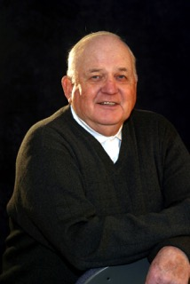

BILL WIITALA
Graduated from Roosevelt HS,(Portland, OR) in 1954
Voted to All-State baseball team in 1954
Selected as 1954 Baseball State Championship MVP
Head baseball coach at Madison HS, Portland
2 State Baseball Championships
Coach of the Year 1961, 1964
22 Years AD at Madison
Established a Fellowship of Christian Athletes Chapter
PIL Hall of Fame Inductee, 1992
PIL HOF Merit Award, 2002
PIL AD of the Year 1987, 1992
Received the Robert Blanchard DSA 1986

