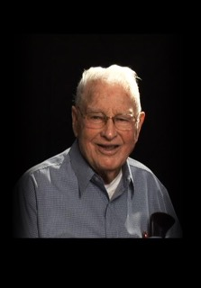

FROSTY LOGHRY
Began his teaching/coaching career in 1946 at Myrtle Creek High School
Officially named Athletic Director in 1950 at Myrtle Creek HS
Upon consolidation with Canyonville School District he became the Athletic Director at South Umpqua HS in 1996, until his retirement in 1981
Baseball coach for both the high school as well as local Babe Ruth program
His baseball teams compiled a 379 – 117 win/loss record with 11 league championships and two state runner-up finishes
Awarded the Babe Ruth Hall of Fame for the Northwest Region in 2003
Served as North-South All Start Honorary Coach in 1982
Inducted into the Oregon Baseball Coaches Hall of Fame in 2001
OADA President in 1979
Named OADA Athletic Director of the Year in 1981
Named First Citizen for Myrtle Creek
Served on the City council for Myrtle Creek
Charter member of the Myrtle Creek Parks Commission

