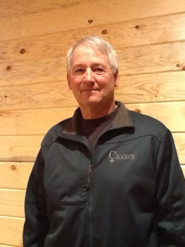

JAKE CAUGHELL

Graduate of Powers HS - 1967
Graduated from SOC – BS 1972, MS 1984
Reedsport HS Head Basketball Coach
FarWest League Coach of the Year 1979, 1982
Two FarWest League Championships
Two Fourth Place Finishes OSAA Tournament
Reedsport Athletic Director 1974 – 2002
FarWest League Rep to OADA

