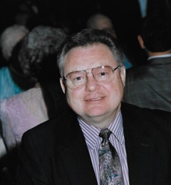

JERRY BRAUNBERGER

Graduate North Dakota State College 1961
Thirty-one year at Cottage Grove SD
Cottage Grove HS AD 1971 – 1980
OADA President 1977 – 1979
Cottage Grove distinguished Service – 1974
Outstanding United Way Volunteer – 1985
OSU – BASF Hall of Fame – 2005
Gene Hansen BASF Award - 2007

