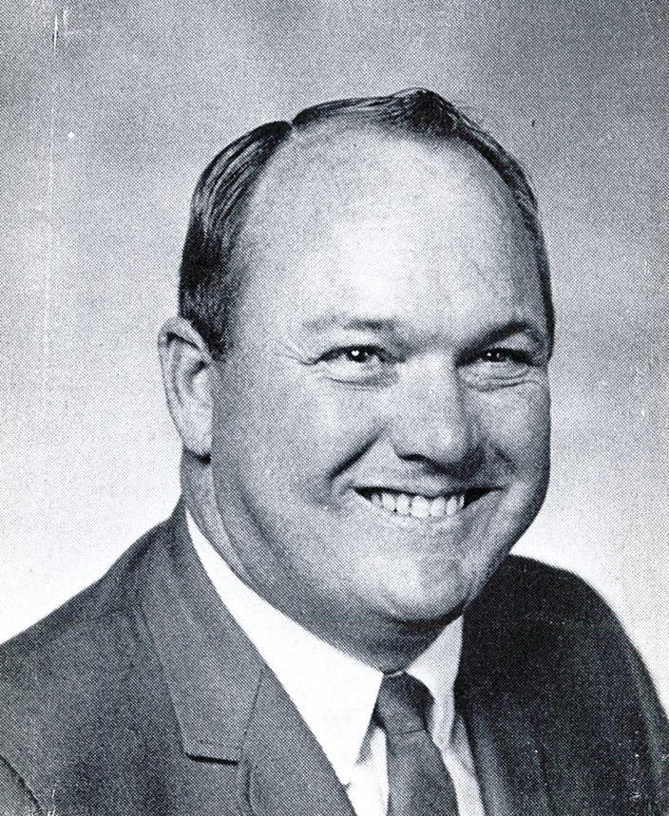

Jack Pinion

The Oregon Athletic Directors Association honors Jack Pinion as a distinguished Athletic Director and a 2019 Inductee to the OADA Hall of Fame. Jack passed on August 2, 2002. Prior to his death Jack lived in Corvallis, Oregon.

Jack was born in Reedsport on the Oregon coast and graduated from Reedsport High School in 1950. He received a scholarship to play football at Oregon State and also played baseball for the Beavers. In 1952 Jack married his high school sweetheart, Shirley Andrews. After graduating from college and a stint in the Air Force, Jack began his 30-year career in education at Corvallis High School in 1956. He taught physical education and coached football, basketball, baseball and golf. For over 15 years, Jack served as athletic and activities director. During his years in athletic administration, Corvallis High won 10 state titles.

Jack also played a large part in the initial organization of the Oregon Athletic Directors Association serving as our third President in 1971-72.

Jack and Shirley have two children: Nancy and her husband Alan of Salem and Paul and his wife Jill of Corvallis. They also have 6 grandchildren.

It is with great pleasure that we have the opportunity to honor his name with induction into our Hall of Fame. We thank him, his wife Shirley and his entire family for their support in his service to the athletes, schools, communities and the State of Oregon. You have made our profession PROUD. Awarded posthumously.

