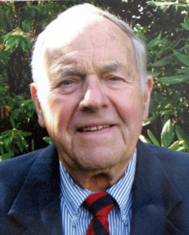

JIM ROTRAMEL
1948 graduate of St. Olaf College, Northfield, MN.
3 year starter on St.Olaf football team
Began teaching/coaching career in 1952
Moved to Parkrose High School, Portland in 1962
Named Athletic Director in 1967, until, his retirement in 1991
Advocate for girls sport programs of basketball and gymnastics
Parkrose hosted the Portland area Special Olympics track meet for 11-years
First OADA President in 1969
24 years as AD at Parkrose HS
Served as Chair of both the Metro
Past President of Oregon High School Coaching Association, (OACA)
Presenter at National Conference of Athletic Directors
Jim passed away in 2014

