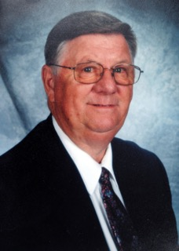

LOU LITTLEJOHN
Oregon born and raised. Graduate of Willamina HS
Linfield College football player, All conference in 1958
1965 – began teaching/coaching at North Salem HS
1979 named Athletic Director at North Salem, until retirement in 1993
OADA President in 1989
4A - AD of the Year in 1992
OADA AD of the Year in 1992
North Salem Football field named Littlejohn Field to honor Lou & Carolyn
Awarded the North Salem Hall of Fame Service Award
Volunteer at numerous OSAA events, basketball, wrestling & track\
Lou passed away in 2014

