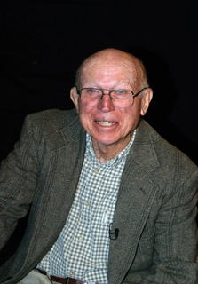

PAUL MANNEN
Began his teaching/coaching career at Boring Grade School in 1959
He moved to Dallas School District with later stops in Hawaii, Washington and California, before settling in at Rainier HS
He served 22 of his 37 year career as an athletic administrator
He was state meet director for wrestling, swimming and track championships
He was President of the COWAPA and PAC-7 conferences
OADA President in 1993
Attained his CAA endorsement from the NIAAA in 1996
Named Athletic Director of the Year in 1995
Served on the NIAAA Awards Committee
Initiated and organized the COWAPA and PAC-7 Scholar Athlete Awards
Wrote and published numerous articles on athletic participation and academic performance
Facilitated retired volunteers to assist in OSAA state championships

