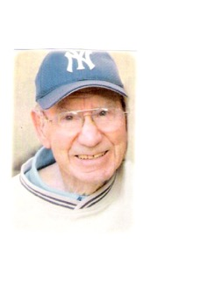
RAYMOND LEROY COLEMAN

1948 graduate of Klamath Union HS
All State Basketball - 1948
All Tournament Basketball 1948
Four Sport Lettermen at OCE
OCE HOF Inductee – 2005
Athletic Director of the Year – 1981
Central HS AD 1962 - 1985
Central HS named Coleman Field in 1981

