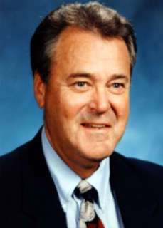
ART BULL
- Career in education spanned thirty-nine years in Washington, Idaho and Oregon
- 1972, Athletic Director/Vice-Principal at The Dalles HS
- Served in leadership roles in his league, on OSAA and OADA committees
- OADA Executive Board President in 1980-81
- Developed the OADA constitution, by-laws and original OADA logo
- Host director baseball all-star game played in The Dalles
- Received numerous awards including: Basketball Coach of the Year and KATU Humanitarian Award
- OADA Athletic Director of the Year in 1981.

