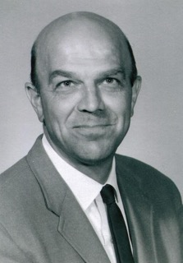
BILL FOELKER
- Graduated from Hillsboro High School in 1940 where he played fullback and was captain of the football team
- Attended Pacific University and played football. With service in the marine corp his graduation was delayed until 1946 then earning a masters degree in Education in 1947
- Began teaching and coaching career at Milwaukie High School in 1947 and was named Athletic Director in 1948
- Recognized as an outstanding World Geography teacher and grand prize winner in 1963
- In 1963 began teaching and serving as Athletic Director at Rex Putnam High School. A position he would hold until retiring in 1982.
- Member of group that organized the Oregon Athletic Coaches Association and served as President in 1963
- In 1985 the football and track and field stadium facility was named in his honor
- Recognized as the Athletic Director of the year by the OADA in 1981

