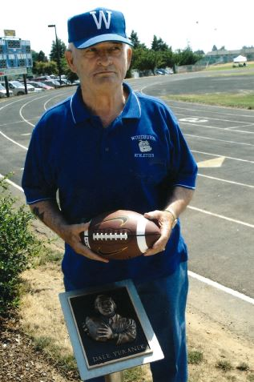

DALE YURANEK
- Graduated from Woodburn High School in 1948
- During high school he earned 10 varsity letters
- Graduated from Western Oregon University in 1962
- Began teaching at Woodburn in 1962 retiring in 1994
- Head football coach for 16 seasons
- Served as Athletic Director from 1970-1994
- Created the first school-to-work program in the state of Oregon
- Inducted into the first Hall of Fame class at Woodburn High School in 2003

