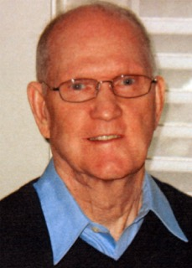

DUANE BRADY
- Powers High School graduate – received all-state recognition in basketball
- Graduate of Lewis and Clark College, all-conference recognition as four year letterman in basketball receiving
- Began his teaching and coaching at Coquille Junior HS, then moved to Reedsport High School
- 1967 led Reedsport High School to state 3A basketball title
- Moved to Centennial High School serving 10 years as teacher/head basketball coach, served 17 years as Athletic Director
- President of the Oregon Athletic Directors Association 1988
- OADA Athletic Director of the Year 1988

