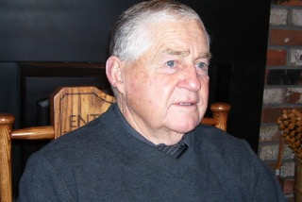
DWAYNE M. HUDDLESTON
- Graduate of Hermiston High School in 1956 where he played basketball and baseball
- Began his college education at Eastern Oregon College and continued at Central Washington University graduating with a degree in education in 1962
- Began teaching at Kittitas, Washington in 1963 followed by 6 years in Umatilla and 25 years in Warrenton
- Served as head baseball coach for 20 years, 14 at Warrenton where he built the program from the ground up
- Athletic Director at Warrenton High School for 22 years. 12 years as league rep to the OADA
- North Coast Basketball of Officials Association commissioner for 13 years
- Selected to the Oregon Baseball Coaches Hall of Fame
- Member of the Warrenton High School Hall of Fame

