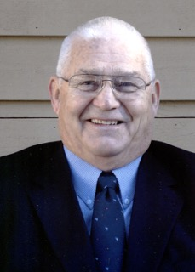
GUY GLEASON
- Outstanding three sport athlete for San Lorenzo Valley High School, Boulder Creek, CA
- Graduate of San Jose State College. Served three years in United States Air Force
- Twenty-eight year career in teaching, coaching at Sunset HS, Aloha HS
- 1973 – 1994 Hillsboro School District Athletic Director - Athletic Director at Hillsboro HS and Glencoe HS
- Served as OADA Executive Board liaison to the OSAA Executive Board
- Developed Metro League Sportsmanship Code of Conduct
- President of the Oregon Athletic Director Association
- OADA Athletic Director of the year 1994

