Jeff Erdman graduated from Madison HS in 1977 and Lewis and Clark College in 1981. That began a forty year teaching, coaching and athletic director career. Jeff received both a MAT and Educational Administrative degree from Lewis and Clark College.

From 1988 through 1999 he was the Head Baseball Coach at both Cleveland and Madison High Schools as well as serving as an assistant coach in both Football and Basketball. Jeff’s 1997 Madison team won the OSAA 4A State Championship. He was honored four times as PIL Baseball Coach of the Year and in 1997 was selected as the Oregon Baseball coach of the Year. Madison won six league championships under Jeff's direction. During Jeff’s baseball coaching career he hosted the 1993 Oregon State AAA Legion Tournament. He also served on the Oregon High School Baseball Coaches association as a Coaches Rep. Jeff has been inducted into the Oregon High School Baseball Coaches and PIL halls of fame as a combination player and coach.

In 1999, Jeff joined the North Clackamas School District as the Athletic Director at Rex Putnam HS. After one year, he moved to Clackamas HS where he spent fourteen years as A.D. before retiring in 2014. Jeff continues to work part-time as an Assistant District Athletic Administrator for the Portland Public Schools. He also attained his CAA certification in 2007 from the NIAAA.

While at Clackamas, Jeff was the Three River’s League AD President twice and hosted numerous district tournaments in Wrestling, Cross Country and Track/Field. He served as the Three River’s League Rep to the OADA, and was elected to the OADA Executive Board as the 4A/6A Classification Representative for a total of six years. During that time, Jeff lobbied the OSAA to allow for more autonomy within individual classifications. This included increasing team sizes for state playoff rosters and out of season practice modifications. He was instrumental in helping design new athletic facilities at Clackamas HS. Those included a partially roofed football stadium, an artificial turf stadium field, two baseball and softball fields, and an all-purpose fieldhouse.

Jeff was selected as the Three River’s AD of the Year in 2007 & 2008 and was honored by the OADA as the 2008 4A and State AD of the Year for Large Schools.

Jeff and his wife Mary recently celebrated their 40th wedding anniversary. They are the proud parents of three daughters. Emily and her husband Adam Wilson,
(grandchildren Edie and Celine); daughter Kelsey and her husband James Buell, and daughter Shelby Madison Erdman.
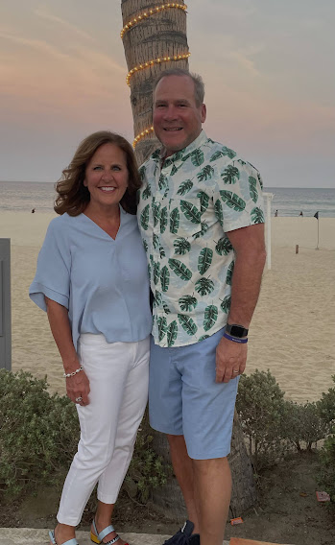

Today, we welcome Jeff Erdman to the OADA Hall of Fame.

