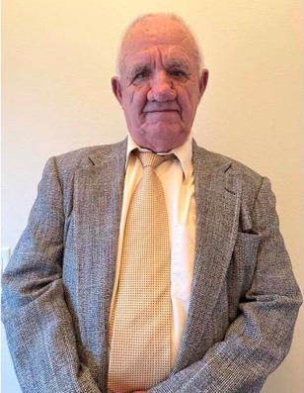

Jerry Scott Snyder

Jerry Snyder was born in 1939 in Maquoketa (muh-KO-kuh-tuh), Iowa. He was one of identical triplets and had one younger brother. The story goes that during their early childhood, the three boys would ride to school on the back of the family St. Bernard.

A 1957 graduate of Lost Nation HS. Jerry entered Upper Iowa University, graduating in 1961 with a degree in Physical Education. Jerry and two fellow graduates then hitchhiked from Iowa to Oakridge, Oregon, where Jerry spent the summer working for the National Forest Service, before beginning a thirty-four year career teaching at Oakridge High School. He continued to work for the Forest Service during the summer prior to entering graduate school at the University of Oregon while he began his teaching career in Physical Education. He also taught some Biology classes.

Jerry was an assistant football coach for numerous years, as well as an assistant basketball coach prior to taking the head coaching position for eight seasons. In 1976, he was named the head baseball coach, a position he held for 17 years. Jerry spent 28 summers coaching the Oakridge Oregon Junior Baseball program. His 1982 high school team had a 21 - 2 record winning the Trico League Championship. They lost in the state championship game 2 -1 to St. Mary’s of Medford. It was during this time Jerry was also named the Athletic Director. He served as Athletic Director and Assistant Principal until his retirement in 1995.

Jerry was named the TRICO League “Coach of the Year” in 1963. In 1965, he was named the Cascade Youth Association “Man of the Year”. Twice named 2A Athletic Director of the Year by the OADA, Jerry was also honored as the Oakridge HS Teacher of the Year in 1994. In 1999, Jerry was inducted into the Oregon High School Baseball Coaches Hall of Fame. Upon retirement, the Oakridge High School gymnasium was named in his honor. Jerry was quoted as saying, “the only reason I coached was because of the kids. I asked players to show up on time, pay attention and play hard.”

Jerry married Lena Wanker in 1969. Lena was the girls Physical Education teacher and coach at Oakridge High School. Their teaching partnership continued throughout their career.

Jerry and Lena have three children and eleven grandchildren. Son Jim and wife Stacey, with children; Gerry, Joel, Twins Sadie and Jade of Oakridge. Son Tracy and wife Megan have three boys; Tate, Jack and Cam of Medford. Daughter Claudine and her husband Joseph Mendazona with children; Peter, Meagan, Lucas (WHO IS Deceased) and Joe Jr of Monmouth.

Life in Oakridge was as sweet as Jerry’s “Blackberry Pie”

Today welcome Jerry Snyder to the OADA Hall of Fame.

