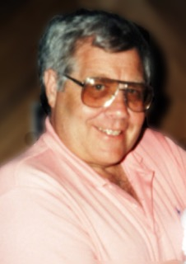

LOYD E. DRAKE
Began teaching/coaching career in 1959 in Springfield School District
Served as Athletic Director at both Thurston and Springfield HS
“Dean” of the Midwestern League AD’s
Won District Basketball Championship as 1st year Head Coach
OADA State AD of the Year 1991
Event Manager for numerous OSAA state championships
Served on numerous OSAA Classification/Districting Committees
31-year educator in Springfield School District
Help establish state cheerleading championships
33 Year Veteran of Army Reserves - retired at rank of Lt. Colonel.

