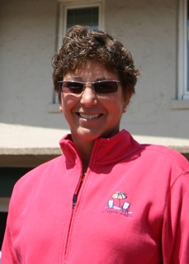

MARGARET STURZA
Redmond HS and Western Oregon University graduate
Began teaching/coaching career in 1977 at Madras High School
16 years head volleyball coach
Appointed Director of Athletics in 1994
Certified as both ASEP and NFHS Fundamental of Coaching presenter
Presenter at numerous state and national conferences for both the NIAAA and AAHPHER
OADA 3A & 5A Classification Rep
Tri-Valley & OADA 3A - AD of the Year in 1999 and 2006
OADA AD of the Year 2006
Director of OSAA 4A/3A/2A/1A golf championships since 2005
Certified OSAA volleyball official
Certified Nationally as a Track & Field Official, working at NCAA and Olympic Trial Meets

