Mary Flande graduated from Scio High School in 1975, where she was a three-sport athlete. She competed in volleyball, basketball and track and field. In Mary’s senior year, her basketball team won the State Championship. She was the OSAA State Shot Put Champion, also in 1975, and that team earned a 2nd place trophy.
She enrolled at Oregon College of Education, graduating in 1978 with a Bachelor’s Degree in Physical Education. She later attained a Masters of Education and Administrative Licensure from the University of Oregon.
She began her teaching career in Nunapitchuck (new-na-pit-chik). Alaska. This was followed by stops at Newport and Madras Junior High Schools prior to her hire at Sisters High School in 1992. Upon opening the new high school, Mary was an assistant Track coach and the Head Girls’ Volleyball and Basketball coach.
In 1994, she was named the Head girls Golf coach and Athletic Director. She felt this was a perfect opportunity to help create a culture where every student felt valued and connected. In addition to an education, she wanted student athletes to be part of an athletic program that was built on integrity, pride, and teamwork. Mary always believed that integrity and honesty were the foundation upon which great things were built.
In her first year as Athletic Director, Mary established an elite Volleyball Invitational Tournament, a Track and Field Invitational Meet, and the Sisters Holiday Basketball Tournament for both boys and girls. All of these events continue to bring excitement and competition to the small community.
Mary’s volleyball teams won 4 conference championships and competed at the OSAA state championships. She was selected Conference Coach of the Year in both 1994 and 1995.
As the Head Girls Golf Coach, Mary built an elite program that won five Conference Championships. Her team won the OSAA State Championship in 2007 and 2008. Mary was honored as the Oregon Girls Golf Coach of the year in both 2007 and 2008. In 2002, Mary was awarded the Northwest Sectional Girls Coach of the Year and NFHS National Girls Golf Coach of the Year.
Sisters High School inducted Mary to their Hall of Fame in 2016 for her accomplishments in Athletic Administration and also in 2021 as Coach of the 2007 and 2008 Girls State Championship Golf Teams.
Mary served many years as a League Rep to the OADA representing the Southern Cascade League, the Capital Conference, and the Sky-Em League as Sisters HS grew and moved from 2A to 3A to 4A classification. She held numerous League Chair positions in each of those leagues, as well as chairing the daunting task for league scheduling. Mary was instrumental in coordinating Central Oregon Middle School programs and athletic directors to develop policy and procedure documents to guide middle school athletics.
Through her 34 year career, Mary worked with many outstanding colleagues. She was grateful to have Larry Johnson of Sweet Home High School and Margaret Sturza of Madras High School as mentors and strong leaders in her journey as an athletic director.
In 2012, Mary retired and spent 7 years as a substitute teacher while volunteering at various athletic events in Sisters. She has traveled to several Pac 12 and NCAA Women’s Basketball Tournaments. Her favorite memory was watching Oregon State defeat DePaul and Baylor in 2017, advancing to the Final Four in Indianapolis.
Mary enjoys playing pickleball, fishing, camping, golfing, quilting, woodworking, and traveling to National Parks.
She would like to thank her parents, Luella and Michael for making it possible to be involved in athletics in Junior High and High School and encouraging her to pursue her dreams in education and athletics.
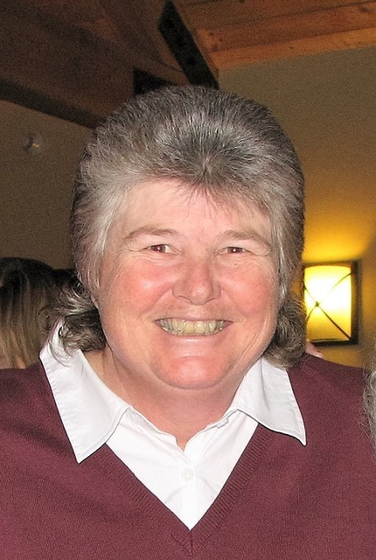
And always, “It’s a great day to be an Outlaw”

Today we welcome Mary Flande to the OADA Hall of Fame.

