Mike Davis

Mike Davis attended St Luke’s College in Exeter, England in 1963, preparing to become a physical education teacher. In 1975, after nine years of teaching and coaching multiple sports at Ashlyn’s School, he immigrated to the United States to attend grad school at the University of Oregon where he received his Phd.

In 1976, he started the Cascade Soccer Camp which he ran for thirty seven years in Oregon and California. He also coached the University of Oregon Club Soccer team for three years prior to moving to the University of Portland as Men’s Head Soccer coach and professor in Anatomy and Education, a position he held for six years. After coaching golf and soccer at Lincoln High School, he became Dean of Health and PE at Mount Hood Community College in 1987. He then moved to Catlin Gabel School in 1988 where he would spend the next twenty-three years as an Educator, Coach and Athletic Administrator. He was the Athletic Director at Catlin Gabel School for seventeen years until his retirement in 2011.

Mike was selected and honored ten times as the State Boys Soccer coach of the Year, four times Regional Soccer Coach of the Year by the NSCAA. Additionally, Mike was chosen as the NFHS National Soccer Coach of the Year in 2005. His Catlin Gabel teams won 19 League Championships and 10 state championships. Mike was honored as the National Soccer Coach of the Year twice in 1990 and 2002.

Mike attained his Certified Athletic Administration certification from the NIAAA in 2002. During his tenure as the Athletic Director at Catlin Gabel, he served the Northwest League and OSAA Special District 1 as the League Chairman, Track and Field Chairman, Golf Chair and District Championship Director, Swimming Chair and Cross Country Chair.

Among his many contributions while at Catlin Gabel, Mike revised the school’s athletic policy manual, revised the Emergency Action Plan, help facilitate the new track and soccer facility, organized and hosted numerous annual soccer jamborees for both boys and girls, all the while finding time to drive the Catlin Gabel School bus for his teams. The Catlin Gabel Soccer field is named after Mike and long time Girls’ Soccer Coach, Brian Gant. His Catlin Gabel teams won forty state championships under his direction. Mike was chosen OADA Athletic Director of the Year in 2000.

Mike’s family include his wife Lucy, daughters Lesley and Laura, Son-in-laws Javier and Fabian and granddaughters Dia and Aria.
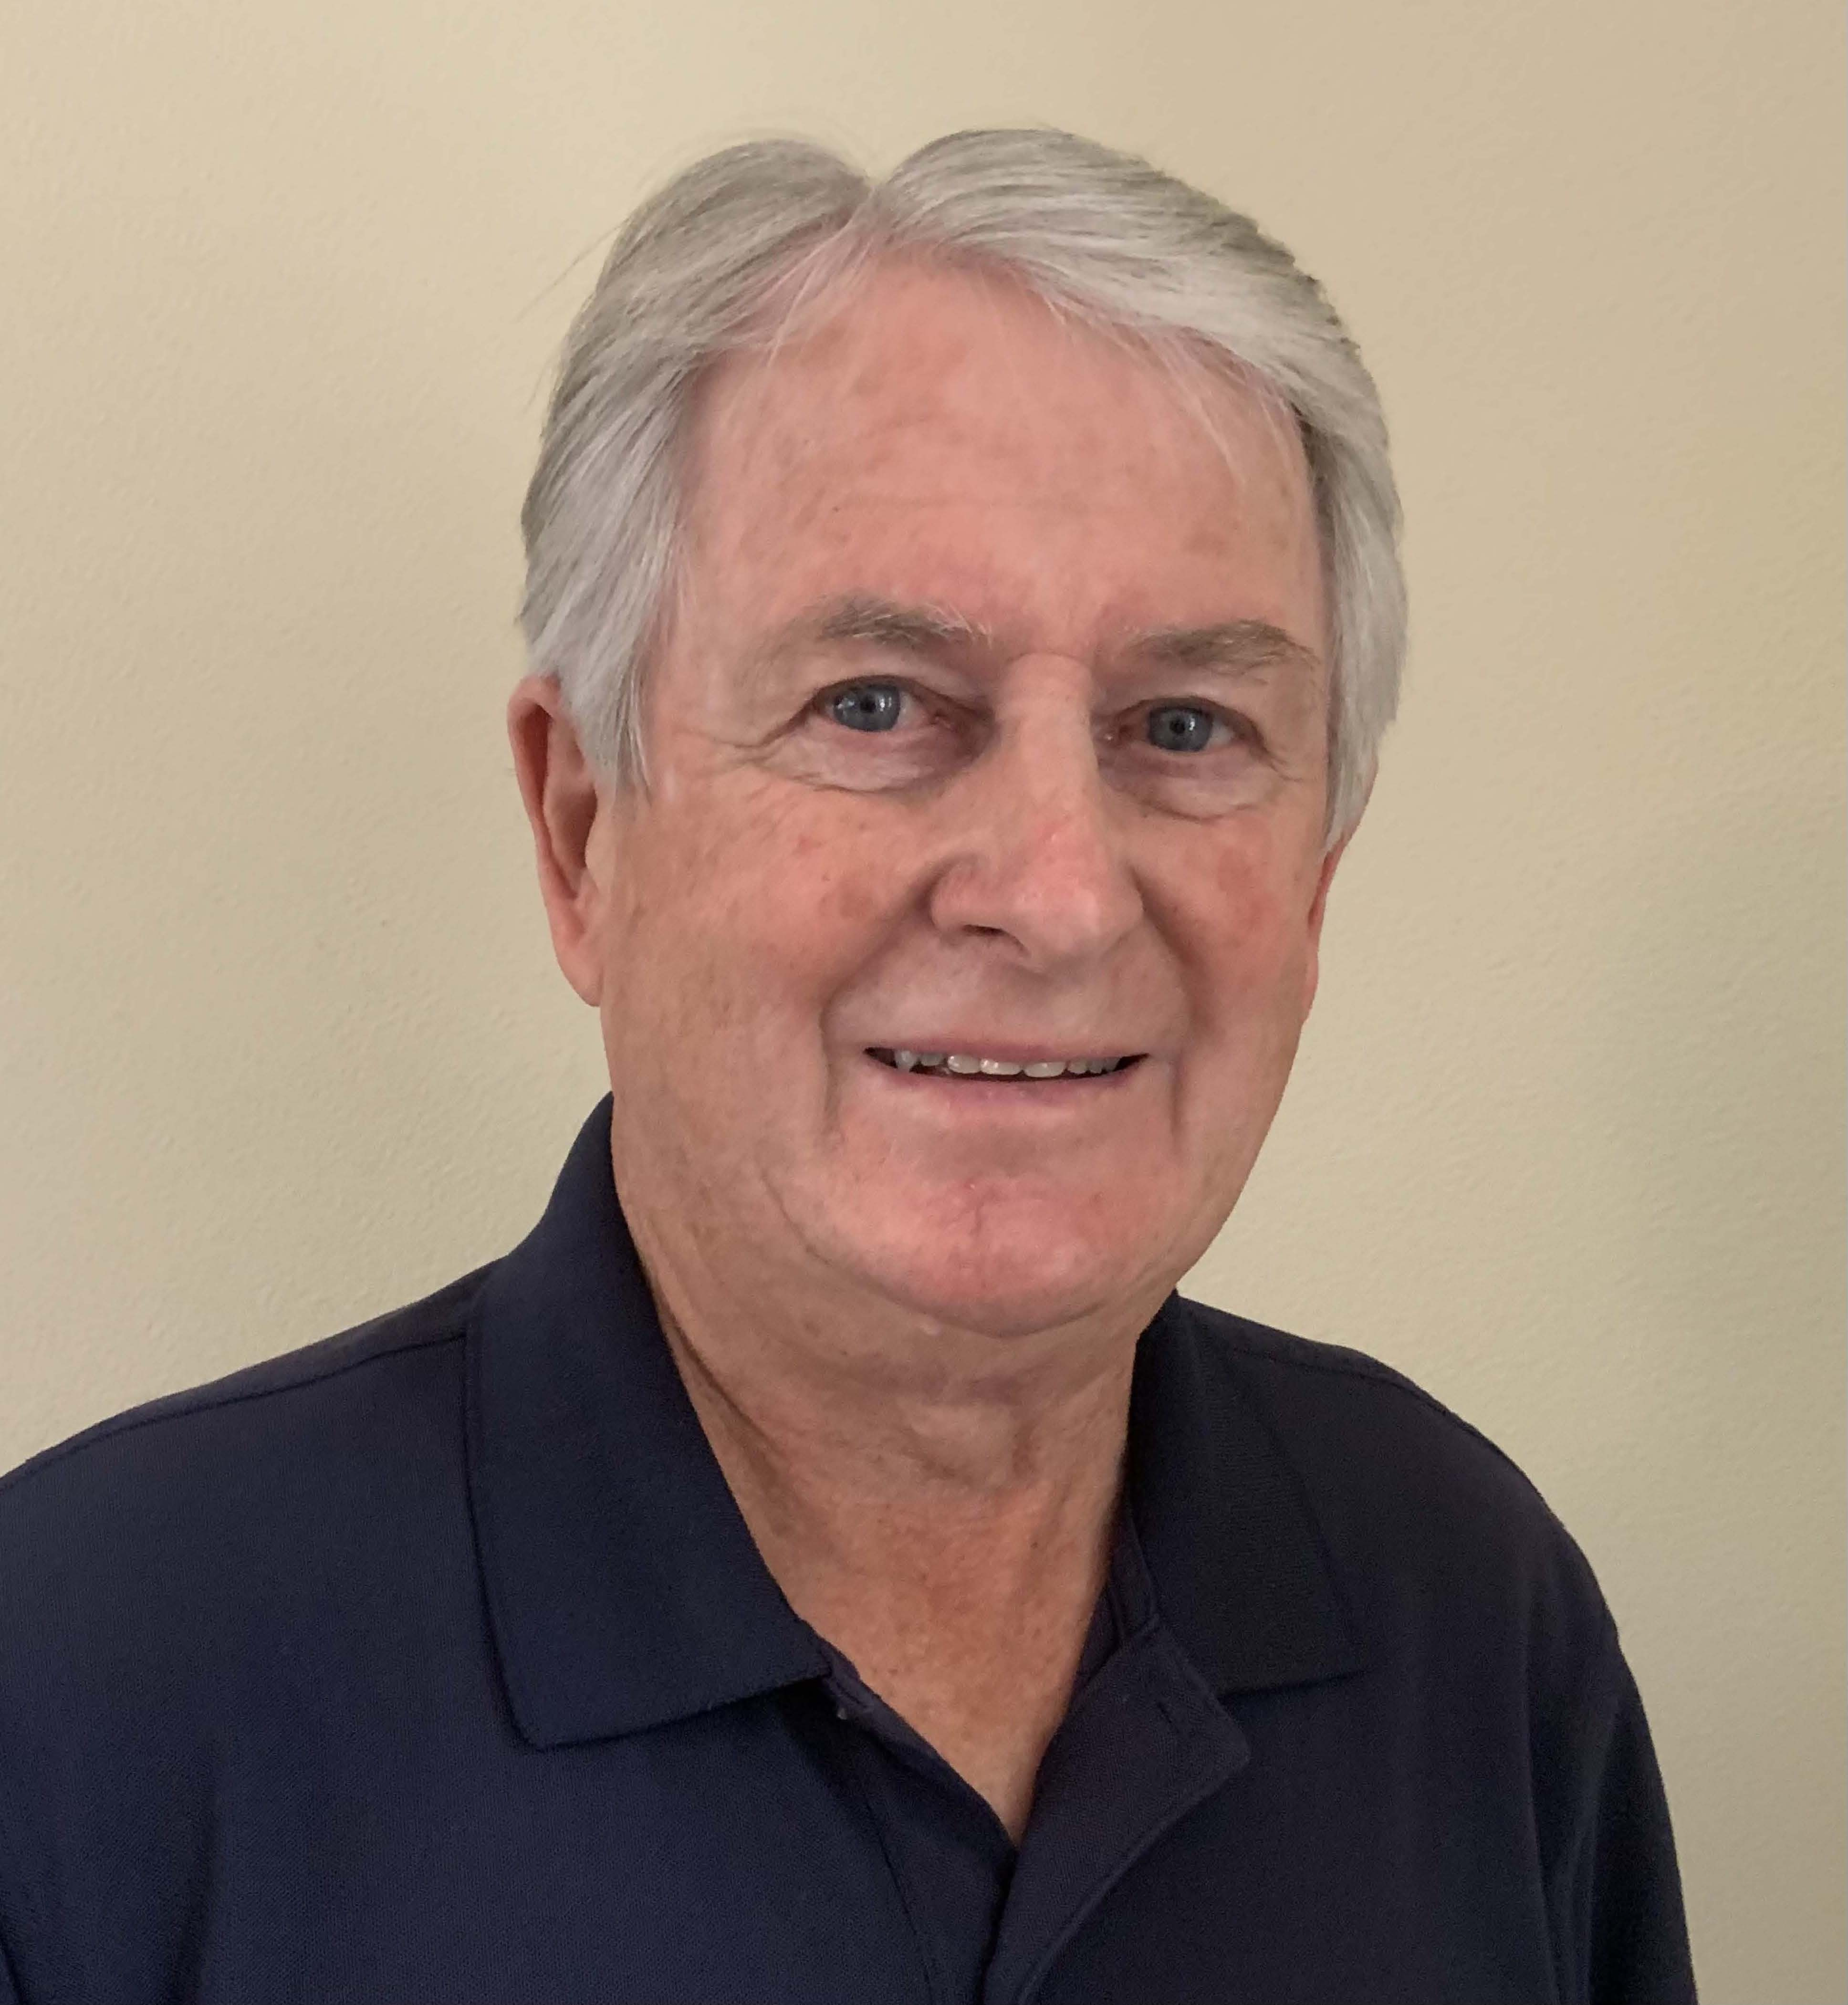

Today, we welcome Mike Davis to the OADA Hall of Fame.

