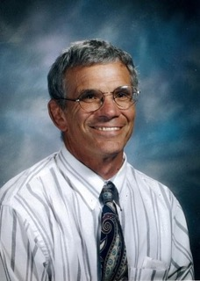

PETE RUSSO
- Graduate of David Douglas High School where he was a state champion wrestler in both 1961 & 1962
- Attended Arizona State University where he was a 4 year letterman in wrestling and was conference champion in 1967
- Taught and coached at Newberg High School from 1968 – 1977 and then at Canby High School from 1977-1984 where he led the wrestling programs and was named state wrestling coach of the year 3 times
- Served as Athletic Director at Newberg High School from 1984 – 1988 and then at West Linn High School from 1988 until retiring in 2000
- Served on the Oregon Athletic Coaches Association executive Board from 1978 – 1983
- Inducted into the Oregon Chapter of the National Wrestling Hall of Fame in 2003
- Member of the David Douglas High School Hall of Fame
- Oregon Athletic Director of the Year in 1995 and Region 8 Athletic Director of the Year in 1996
- Received the National Federation of State High School Citation Award

