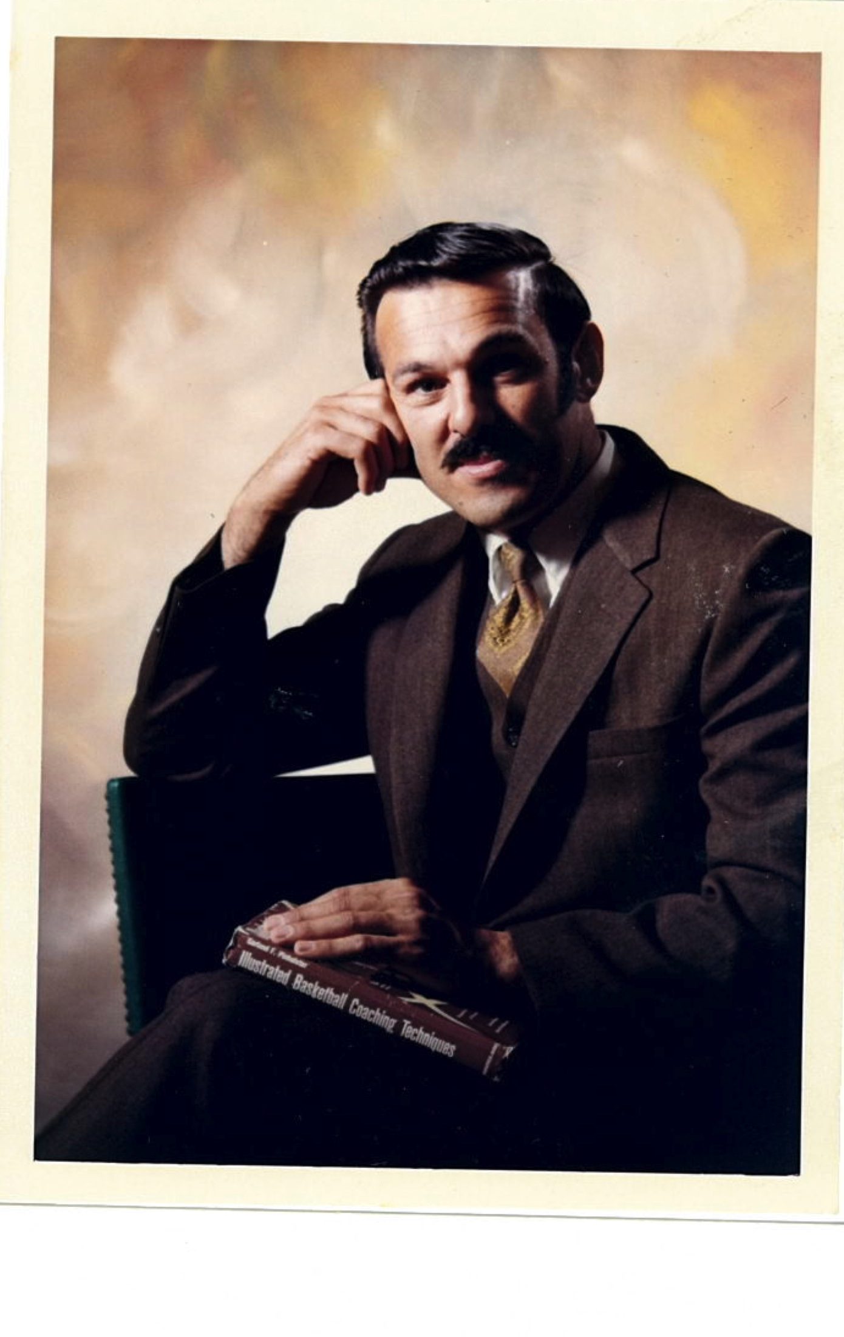
GEORGE MILIONIS
- Graduated from Kellogg High School in northern Idaho where he was as a standout basketball player for the Wildcats
- Attended Washington State University on a basketball scholarship. Served in the army overseas for two years. Completed his education at Humboldt State University where he played on the basketball team for three years graduating in 1957
- Began teaching and coaching at Wellpinit (3 years) followed by two years at Prescott, WA. In 1966 he began teaching and coaching at Cascade High School
- Began serving as Cascade High School and Middle School Athletic Director in 1968, a position he would hold for twenty-seven years
- Lead many facility improvement projects during his tenure at Cascade High School
- Provided service to the OSAA helping to run the 3A boys golf tournament for fifteen years
- Was recognized as the Oregon Athletic Directors Association Athletic Director of the Year in 1985
- In 1987 named Athletic Director of the Year by NCSSAD and in 1995 recognized as the Northwest Athletic Director of the Year

