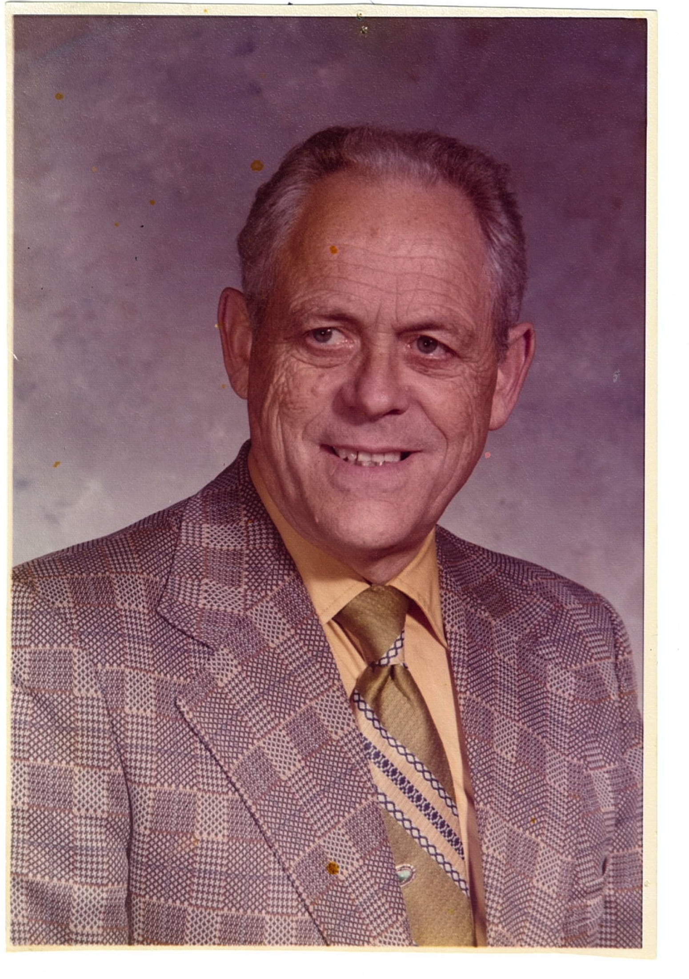
JESSE LOFFER
- Graduated from high school in Myrtle Creek, Oregon where he was a standout baseball player
- Attended Oregon State University on a baseball scholarship graduating in 1940 with a Bachelor of Science degree in 1940. In 1951 he received a Masters Degree from the University of Oregon
- Started teaching and coaching at Junction City High School in 1940. Served in the navy from1942-1945. Began teaching and coaching at Grants Pass High School in1945.
- Served as Athletic Director for Grants Pass High School from 1947-1980 (33 years)
- Grants Pass programs won ten state titles during his tenure
- Served as president of the Oregon Athletic Directors Association
- Twice named Northwest Regional Athletic Director of the Year (1976-1978)
- Inducted into the Grants Pass Hall of Fame

