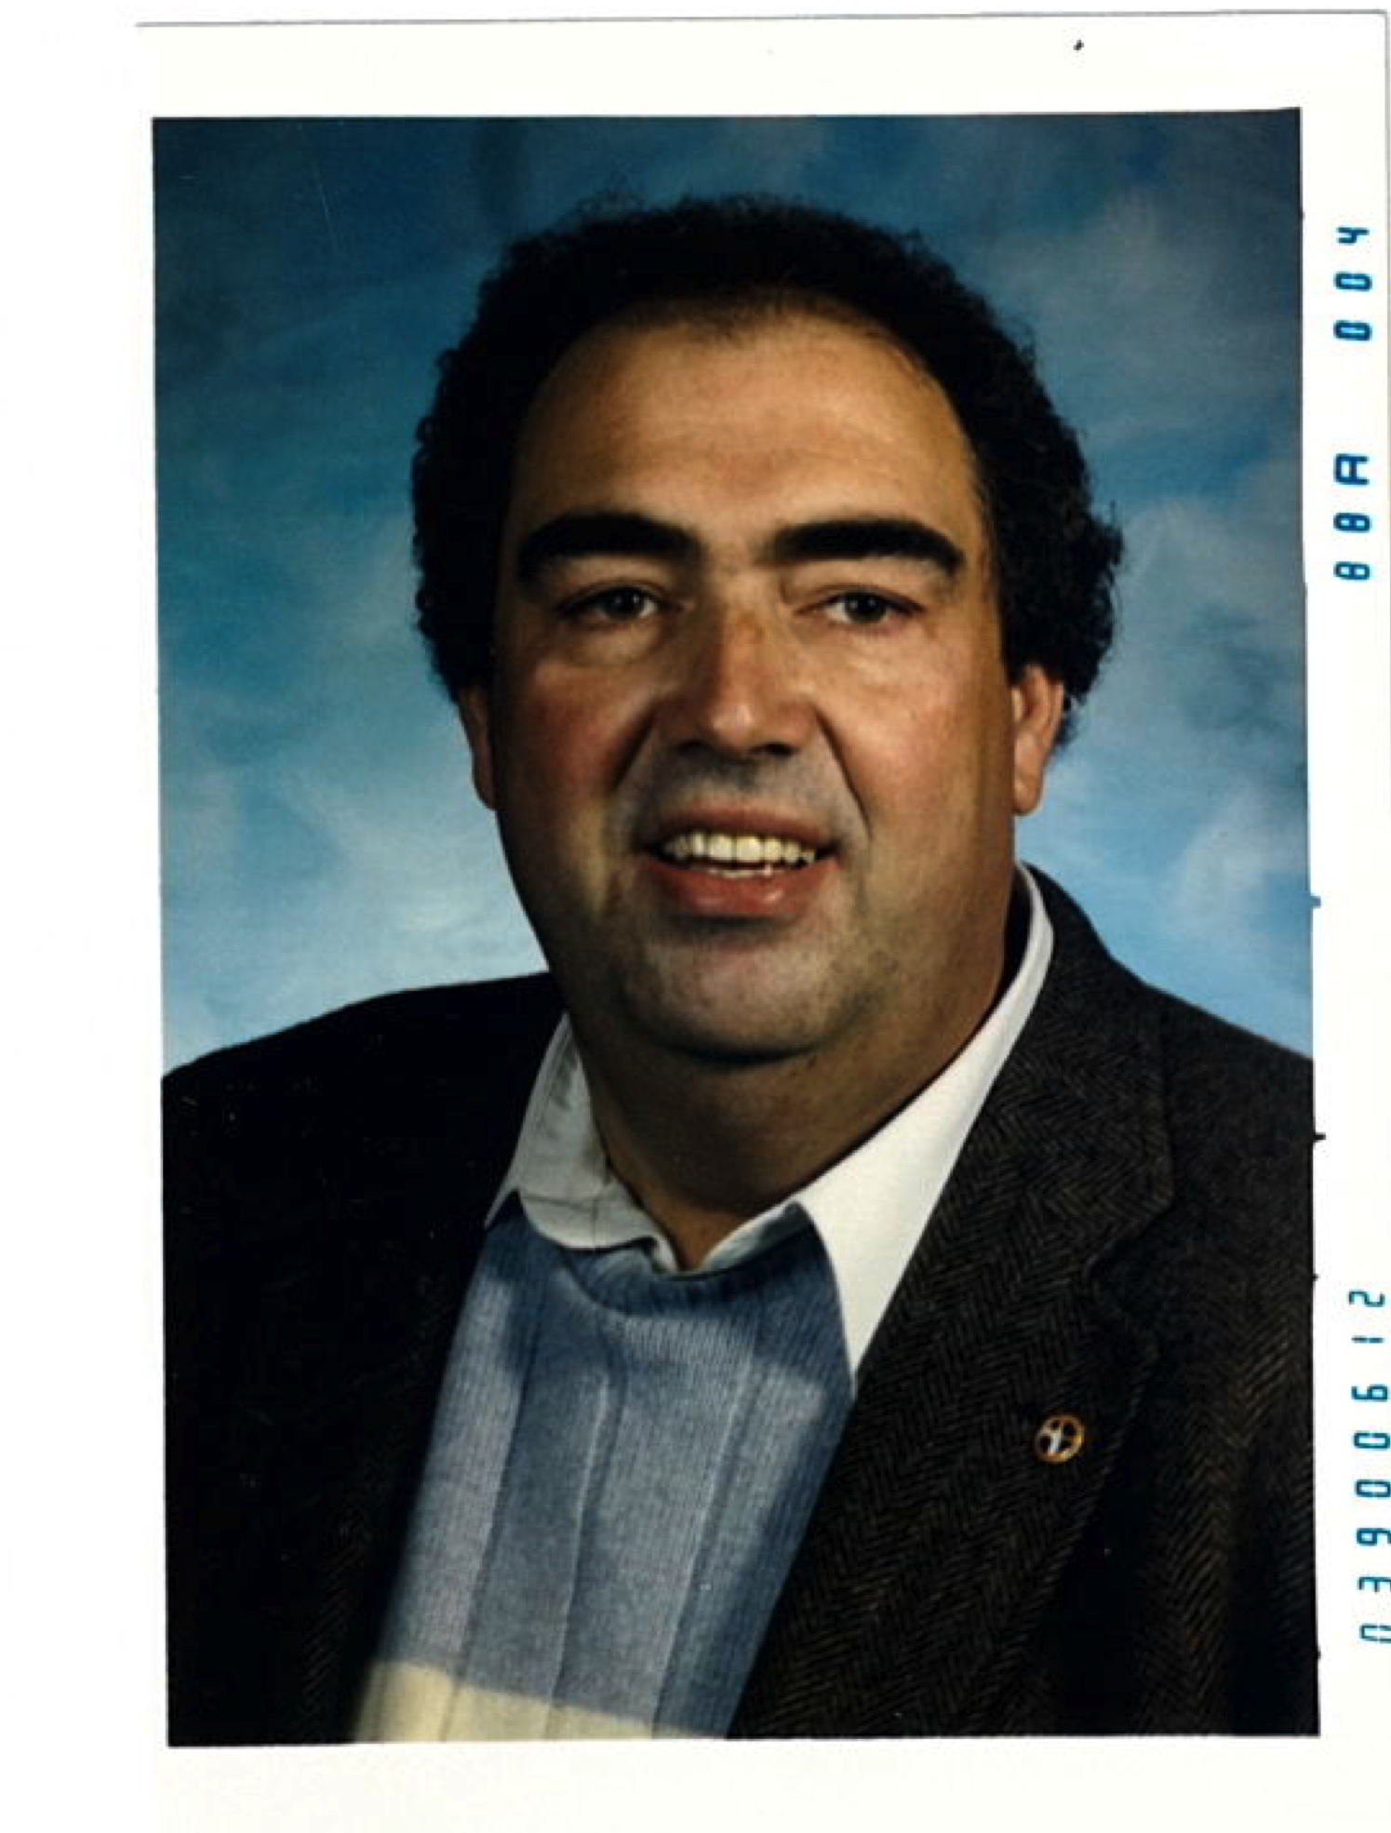

MIKE KOSTRBA
- Outstanding three sport student athlete at Reynolds High School graduating in 1960
- Graduated from Lewis and Clark College where he was recognized as a Little All-American football player
- Began his teaching and coaching career at Kelso High School returning to Oregon to teach and coach at Gladstone High School
- Served ten years as the Athletic Director at Sandy High School followed by eight years as Athletic Director at Benson High School
- Served as president of both the Oregon Athletic Directors Association and the Oregon High School Coaches Association
- Served as the OADA representative to the Oregon Schools Activities Association and as the Oregon representative to both the National Interscholastic Athletic Administrators Association and the national Federal of Interscholastic Coaches Association
- Honored by the establishment of the Michael Kostrba Athletic Scholarship Foundation and the renaming of the Sandy High School Track Invitational to the Annual Michael Kostrba Sandy High School Invitational track Meet

