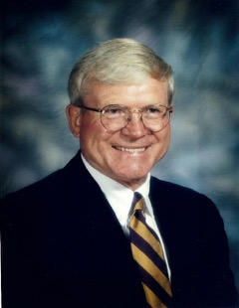

TOM JENKINS
- Graduate of Marshfield High School in 1958. Played football and wrestled. 3 years varsity football player on teams that won 2 state titles. Placed 3 years in state wrestling tournament
- Attended the University of Oregon and California State University at Chico where he played football, wrestled and baseball graduating in 1961
- 40 years career in education with 2 at Mount Shasta in California and 38 in the Coos Bay School District
- Teaching at both the junior high and high school from 1965 – 1981 then becoming Athletic Director in 1982 until retiring in 2002
- Coaching football, wrestling and baseball through his entire career. Served as head wrestling coach from 1981 – 1984 winning district titles in 1982 - 1984
- Hosted the OSAA State 3A wrestling tournament for 7 years
- Organized and promoted numerous fundraising projects to support athletics including maintaining programs when they were zero funded one year
- Selected as the 4A Athletic Director in 2000 by the OADA

