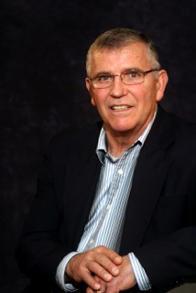

VERN PETRICK

Graduate of Klamath Union HS in 1964
Coached football and wrestling at Willamette University and Southern Oregon University
Named Athletic Director in 1982 at Glencoe High School, Hillsboro
OADA President 1994
Established Glencoe Youth Programs
Awarded the Hillsboro Distinguished Achievement Award in 1992
OADA AD of the Year 1995
NIAAA State Award of Merit 1996
Chamber of Commerce DSA 1995
METRO League Wrestling Chair, 21 years
Served on Numerous OSAA Committees
Works to support Parkinson Center of Oregon

